|  |  |
| --- | --- |
| \\VFILERDPI\DPI-Home\OBRIENR2\My Documents\Downloads\PP logo.jpg |  |
| **COUNCIL ASSESSMENT REPORT**  HUNTER AND CENTRAL COAST REGIONAL PLANNING PANEL | |

|  |  |
| --- | --- |
| PANEL REFERENCE & DA NUMBER | PPSHCC-152 [DA3119/2022] |
| PROPOSAL | Removal of five (5) demountable buildings and construction of a three storey resources hub within the grounds of the Central Coast Adventist School. |
| ADDRESS | Lot 82 DP 1108157 [12 Penrose Crescent, Erina] |
| APPLICANT | Seventh-day Adventist Schools (North New South Wales) Ltd |
| OWNER | Seventh-day Adventist Schools (North New South Wales) Ltd |
| DA LODGEMENT DATE | 2 November 2022 |
| APPLICATION TYPE | DA Integrated-NSW Rural Fire Service |
| REGIONALLY SIGNIFICANT CRITERIA | Clause 5 Schedule 6 of *State Environmental Planning Policy (Planning Systems) 2021* as it comprises private infrastructure and community facilities over $5 million. |
| CIV | $ 10,441,675.00 (excluding GST) |
| CLAUSE 4.6 REQUESTS | N/A |
| KEY SEPP/LEP | SEPP (Planning Systems) 2021, SEPP (Transport and Infrastructure) 2021, Central Coast Local Environmental Plan 2022. |
| TOTAL & UNIQUE SUBMISSIONS KEY ISSUES IN SUBMISSIONS | No submissions |
| DOCUMENTS SUBMITTED FOR CONSIDERATION | * Architectural Plans * Landscape Plan * Survey Plan * Erosion and Sedimentation Control Plan * Waste Management Plan * Traffic and Parking Assessment * Stormwater Management Plan * Statement of Environmental Effects * Geotechnical Assessment * Bushfire Assessment * BCA Compliance Capability * Acoustic Assessment * Accessibility Design Review * Section J Report |
| SPECIAL INFRASTRUCTURE CONTRIBUTIONS (S7.24) | None |
| RECOMMENDATION | Approval |
| DRAFT CONDITIONS TO APPLICANT | Yes |
| SCHEDULED MEETING DATE | 1 March 2023 |
| PLAN VERSION | Version B-21/09/2022, Version C-28/09/2022 |
| PREPARED BY | Robert Eyre |
| DATE OF REPORT | 18 January 2023 |

**EXECUTIVE SUMMARY**

The development application (DA/3119/2022) seeks consent for the removal of 5 existing demountable buildings, and the construction of a three (3) storey resource hub within the grounds of the Central Coast Adventist School.

The proposed resource hub will contain the following facilities:

* Ground floor- school reception, staff offices and associated facilities.
* First Floor- information area containing books, seating, student study area, tutorial rooms, staff offices facilities and communication and technology hub.
* Second floor- Literacy hub for teachers, student study pods, staff facilities and general learning area.

Lift and stair cores will provide access within the building and an elevated covered walkway will connect the proposed building to the existing secondary school learning areas.

The proposed building will be the front door to the site and the centre of the school operations.

The subject site is known as 12 Penrose Crescent, Erina (‘the site’) and comprises three (3) road frontages including Penrose Crescent to the north, Karalta Lane to the west and Miranda Close to the south. The site occupies an irregularly shaped area of 4.62 ha. There are multiple vehicle access points to the site, including from Penrose Crescent, Karalta Lane and Miranda Avenue.

Existing development on the site consists of a number of buildings, with the main access point being from Penrose Crescent.

The school has been operating since 1973 and caters for students from Kindergarten to Year 12. The school has approx. 1000 students and 114 FTE staff.

There are 89 onsite car parking spaces with 55 spaces off Penrose Crescent and 34 spaces off Karalta Lane. A drop-off provision is provided internally with access from Penrose Crescent, Karalta Lane and Miranda Avenue.

The site is located in an area of commercial/retail use and is located between the Central Coast Highway and Erina Fair shopping centre.

The site is located in the SP2–Infrastructure zone (Educational Establishment) under Central Coast Local Environmental Plan 2022. Educational Establishments are a permissible use with consent.

The principle planning controls relevant to the proposal include *State Environmental Planning Policy (Transport and Infrastructure) 2021, Central Coast Local Environmental Plan 2022 and Central Coast Development Control Plan 2022.*

The proposal is consistent with various provisions of the planning controls including:

* The proposal is considered to be comply with the various objects of the EP&A Act (orderly and economic development of land) and is not contrary to the public interest given it is consistent with various planning controls.
* The proposal also complies with the matters for consideration under Section 4.15(1) of the EP& A Act in relation to potential impacts to surrounding area.

The application is integrated development pursuant to Section 4.46 of the *Environmental Planning and Assessment Act 1979* (‘EP&A Act’)*.* A referral to NSW Rural Fire Service pursuant to *Rural Fires Act* 1997 was sent and RFS have issue GTAs subject to conditions.

The application was placed on public exhibition from 11 November 2022 to 2 December 2022 with no submissions being received.

The application is referred to the Hunter and Central Coast Regional Planning Panel (‘the Panel’) as the development is ‘*regionally significant development’*, pursuant to Section 2.19(1) of *State Environmental Planning Policy (Planning Systems) 2021* as the proposal is development for an educational establishment with a CIV over $5 million.

A briefing was held with the Panel on 1 December 2022 where key issues were discussed, including zoning and permissibility, access and car parking, past consents, and internal and external impacts during construction.

The key issues associated with the proposal included:

1. *Permissibility* - The proposal is permissible is permissible with consent in the SP2 zone.
2. *Urban Design* - The proposal is consistent with the existing development on the site and the surrounding area. The replacement of demountable buildings with a new 3 storey building will improve the school street address and entry statement.
3. *Bulk and Scale* - The bulk and scale of the proposal is compatible with the existing prevailing character of the surrounding commercial/retail area. There are no height and FSR development standards applicable to the site.
4. *Traffic and Car Parking* - There is no proposal to increase student or staff numbers and no requirement for additional parking on the site. No additional access driveways to the site are proposed.

Following a detailed assessment of the proposal, pursuant to Section 4.16(1)(b) of the *EP&A Act*, DA/3119/2022 is recommended for approval subject to the conditions contained in **Attachment A** of this report.

1. **THE SITE AND LOCALITY**
   1. **The Site**

* The site has an area of 4.62 ha and is of an irregular shape. The site falls towards to the south- west to a watercourse on the southern site of the site. The watercourse and adjoining land to the south is heavily vegetated. The school buildings are generally located on the northern elevated part of the site, with playing fields and associated sheds located on the southern side where the land is flatter.
* Special features – The site contains the existing K-12 Adventist school. The site is not subject to any heritage items.
* On the northern side of the site, between the car parking area and Penrose Crescent there is an existing stormwater detention/nutrient control facility.

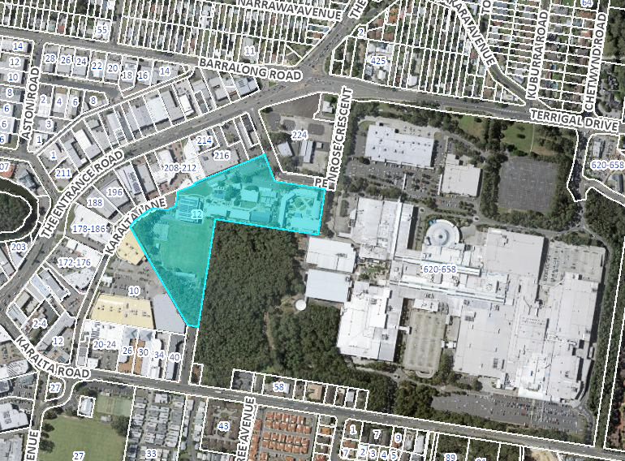

**Figure 1-Locality Map**

* 1. **The Locality**
* The site is surrounded by commercial and retail uses. To the east, north and south is Erina Fair shopping centre. To the south on the opposite side of Karalta Road is a manufactured home estate. To the west are a number of commercial/retail/bulky goods outlets including Harvey Norman, pathology collection centre.
* The site is close to major roads and public (bus) transport links within Erina Fair and along the Central Coast Highway and Terrigal Drive.

1. **THE PROPOSAL AND BACKGROUND** 
   1. **The Proposal**

The development application seeks consent for the removal of 5 existing demountable buildings, and the construction of a three (3) storey resource hub within the grounds of the Central Coast Adventist School.

The proposed resource hub will contain the following facilities:

* Ground floor- school reception, staff offices and associated facilities.
* First Floor- information area containing books, seating, student study area, tutorial rooms, staff offices facilities and communication and technology hub.
* Second floor- Literacy hub for teachers, student study pods, staff facilities and general learning area.

The existing school operates hours Monday to Friday 8.00am to 4.00pm. These hours are not proposed to change. **(Refer condition 9.3)**

**Table 1: Development Data**

|  |  |
| --- | --- |
| **Control** | **Proposal** |
| Site area | 4.62 ha |
| GFA | 2553 m2 |
| FSR | N/A |
| Clause 4.6 Requests | N/A |
| Max Height | N/A |
| Landscaped area | Landscape plan submitted. |
| Car Parking spaces | 88 existing spaces |
| Setbacks | 19.02m to Penrose Crescent |

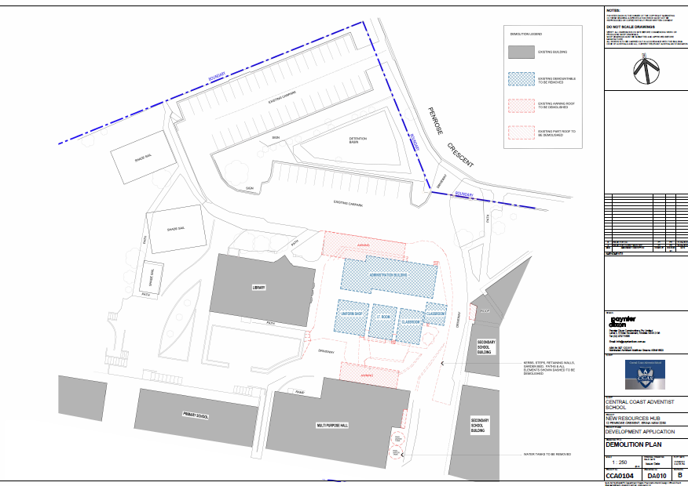

**Figure 2-Demolition Plan**

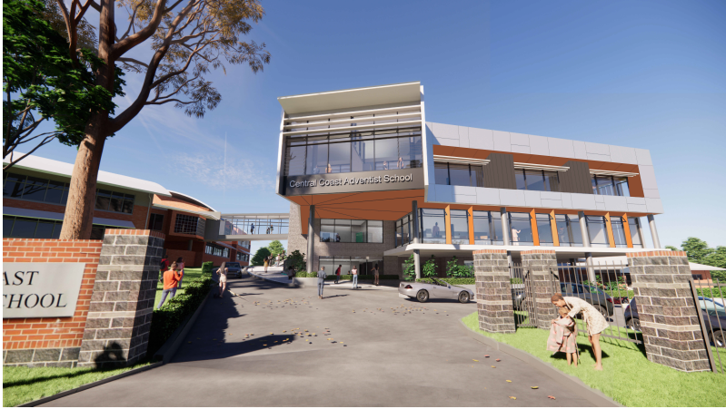

**Figure 3-Proposed Entry View**

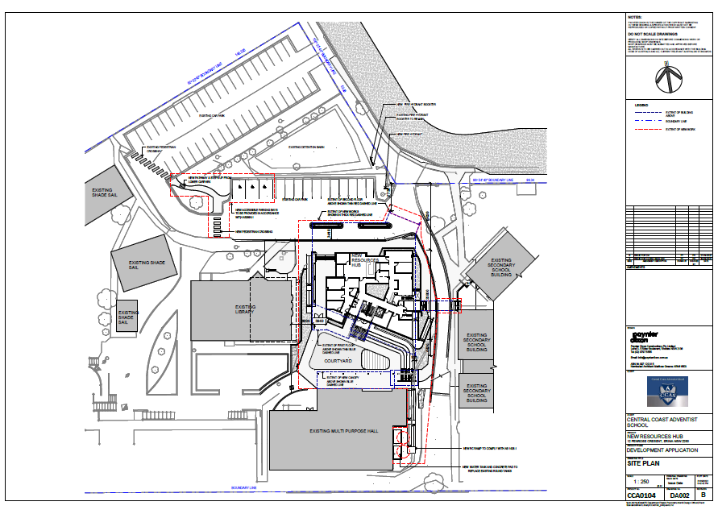

**Figure 4-Site Plan**

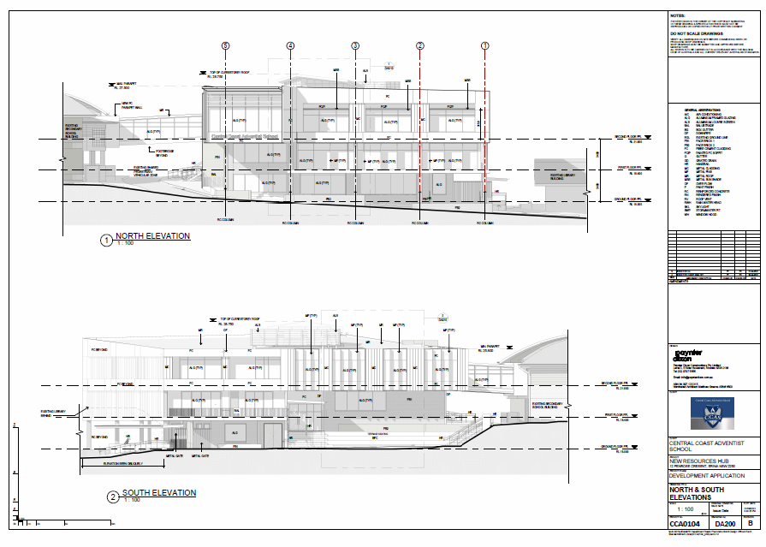

**Figure 5-North and South Elevations**

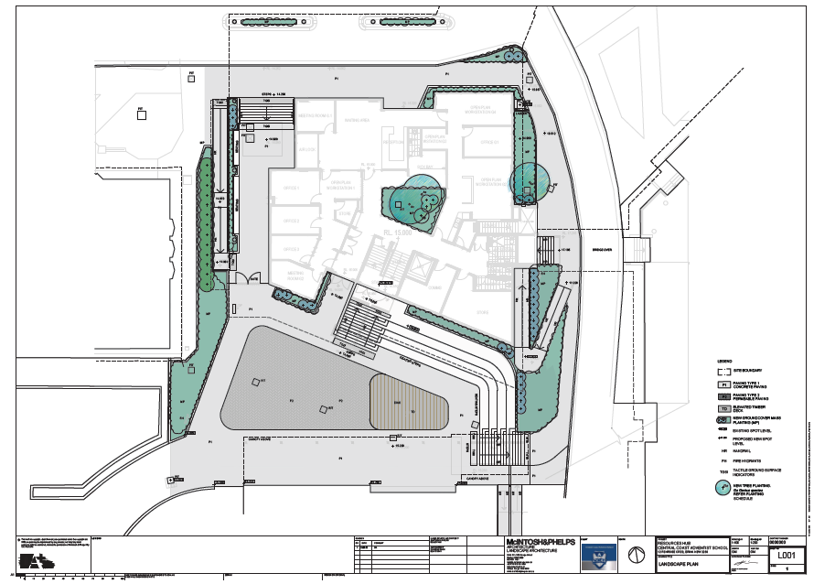

**Figure 6-Landscape Plan**

* 1. **Background**

A pre-lodgement meeting was held prior to the lodgement of the applicant on 26 July 2022 where various issues were discussed. A summary of the key issues and how they have been addressed by the proposal is outlined below:

* Bushfire-integrated development with RFS.
* Watercourse on southern end of site. Work not within 40m and a CAA under *Water Management Act* 2000 is not required.
* Contamination
* Water cycle Management
* Traffic and car parking impact.

The development application was lodged on **2 November 2022**. The application was accompanied by documents and plans which address the matters raised in the pre-lodgement meeting.

A chronology of the development application since lodgement is outlined below including the Panel’s involvement (briefings, deferrals etc) with the application:

**Table 2: Chronology of the DA**

|  |  |
| --- | --- |
| **Date** | **Event** |
| 26 July 2022 | Pre-lodgement meeting. |
| 2 November 2022 | DA lodged 2 November 2022 |
| 11 November 2022 | Exhibition of the application 11 November 2022 to 2 December 2022 |
| 2 November 2022 | DA referred to external agencies |
| 14 November 2022 | Request for Information from Council to applicant |
| 21 November 2022 | Amended Erosion and Sedimentation Plan |
| 1 December 2022 | Panel briefing |
| 7 December 2022 | Site Inspection |
| 13 December 2022 | GTAs from RFS received. |
| 17 January 2023 | Applicant response to draft conditions. See comments below. |

The Panel identified the following issues at the 1 December 2022 briefing:

* The Panel will need to understand how the proposal relates to any existing consents to make sure no inconsistencies arise and make sure the fundamentals of those consent are still appropriate e.g. secondary kiss and ride, hours, student numbers etc.
* The Panel will also want to understand the new uses to be accommodated in the new building and how this relates to the existing uses. It was noted that the future use of the existing library is not included in the current application. It may be appropriate for these works to be included.
* A construction and traffic management plan will be critical for the Panel and Council to understand and consider impacts associated with the proposed temporary arrangements, staging, disruption to existing uses within the demountable buildings and interactions with students and parents.
* Council’s assessment should outline any issues associated with the current school operations.
* The Panel expects the Council to promptly issue an RFI, if required, prior to the Christmas break.
* The Panel will want to undertake a collective site visit/briefing in the New Year.

With regard to the above the following comments are provided:

* There are no existing consents which conflict or are inconsistent with the current proposal. The additional driveway, car parking and pick up/drop off from Miranda Avenue and Karalta Lane have been completed and operating.
* The future use of the existing library is not part of this application and may be subject to a future application depending on the school’s future plans.
* A construction and traffic management plan is required as a condition of consent. This is to minimise disruption both to school operations and external impacts on the road system.
* There are no significant issues with the current school operations. Traffic and parking issues have significantly improved since construction of the additional driveway and car parking area off Karalta Lane.
* No RFI was issued after the Panel briefing.
* A site inspection was carried out by Council assessment staff on Wednesday 7 December 2022.

**Applicant’s Response to draft conditions.**

The draft conditions were provided to the applicant. The school raised issues regarding the school operating times and the construction times.

While the school operates Monday to Friday 8.00am to 4.00pm, other activities such as school presentation nights and sporting/community activities use the facility outside school hours.

Also daily construction times should be extended to minimise the time to complete the development and therefore reduce the total time of impact on school operations and the surrounding road network.

As there are no sensitive nearby receptors such as residential development extended hours/days of construction are supported. **(Refer conditions 5.2, 5.11, 5.12, and 9.3).**

* 1. **Site History**
* The school has been the subject of a number of applications over the years since it was established. The latest being DA/56520/2019 granted consent on 26 July 2019 for an Integrated new driveway, including access bridge, two new gates, car parking area off Karalta Lane, and new primary school drop off/pick up zone. The development under this consent has been completed. This new area is proposed by the school to be utilised by the school during construction of the current proposed development to temporarily relocate all drop off/pick up operations to for both high school and primary school.
* Prior to the above DA/48630/2015 granted consent on 21 December 2015 for front entry gates and fencing.
* There are no concurrent applications currently being considered.

1. **STATUTORY CONSIDERATIONS**

When determining a development application, the consent authority must take into consideration the matters outlined in Section 4.15(1) of the *Environmental Planning and Assessment Act 1979* (‘EP&A Act’). These matters as are of relevance to the development application include the following:

1. *the provisions of any environmental planning instrument, proposed instrument, development control plan, planning agreement and the regulations*

*(i)  any environmental planning instrument, and*

*(ii)  any proposed instrument that is or has been the subject of public consultation under this Act and that has been notified to the consent authority (unless the Planning Secretary has notified the consent authority that the making of the proposed instrument has been deferred indefinitely or has not been approved), and*

*(iii)  any development control plan, and*

*(iiia)  any planning agreement that has been entered into under section 7.4, or any draft planning agreement that a developer has offered to enter into under section 7.4, and*

*(iv)  the regulations (to the extent that they prescribe matters for the purposes of this paragraph),*

*that apply to the land to which the development application relates,*

1. *the likely impacts of that development, including environmental impacts on both the natural and built environments, and social and economic impacts in the locality,*
2. *the suitability of the site for the development,*
3. *any submissions made in accordance with this Act or the regulations,*
4. *the public interest.*

These matters are further considered below.

It is noted that the proposal is considered to be (which are considered further in this report):

* Integrated Development (s4.46) with NSW Rural Fire Service.
  1. **Environmental Planning Instruments, proposed instrument, development control plan, planning agreement and the regulations**

The relevant environmental planning instruments, proposed instruments, development control plans, planning agreements and the matters for consideration under the Regulation are considered below.

1. **Section 4.15(1)(a)(i) - Provisions of Environmental Planning Instruments**

The following Environmental Planning Instruments are relevant to this application:

* [*State Environmental Planning Policy (Biodiversity and Conservation) 2021*](https://legislation.nsw.gov.au/view/html/inforce/current/epi-2021-0722)
* [*State Environmental Planning Policy (Resilience and Hazards) 2021*](https://legislation.nsw.gov.au/view/html/inforce/current/epi-2021-0730)
* [*State Environmental Planning Policy (Transport and Infrastructure) 2021*](https://legislation.nsw.gov.au/view/html/inforce/current/epi-2021-0732)
* *Central Coast Local Environmental Plan 2022.*

A summary of the key matters for consideration arising from these State Environmental Planning Policies are outlined in **Table 3** and considered in more detail below.

**Table 3: Summary of Applicable Environmental Planning Instruments**

|  |  |  |
| --- | --- | --- |
| **EPI** | **Matters for Consideration** | **Comply (Y/N)** |
| State Environmental Planning Policy (Biodiversity & Conservation) 2021 | No native vegetation is proposed to be removed or impacted. Not applicable | Y |
| State Environmental Planning Policy (Planning Systems) 2021 | Chapter 2: State and Regional Development   * Section 2.19(1) declares the proposal regionally significant development pursuant to Clause 5 of Schedule 6 as it comprises private infrastructure and community facilities over $5 million. | Y |
| SEPP (Resilience & Hazards) | Chapter 2: Coastal Management   * Section 2.10(1) & (2) - Development on land within the coastal environment area.   Chapter 4: Remediation of Land   * Section 4.6 - Contamination and remediation has been considered and the proposal is satisfactory. | Y |
| State Environmental Planning Policy (Transport and Infrastructure) 2021 | The site is not located on a classified road and there is no increase in student or staff numbers. Referral to TfNSW was not required.  Chapter 3: Educational Establishments.  Clause 3.36(6) consideration of design quality principles set out in schedule 8 of the SEPP. See table. | Y |
| Proposed Instruments | No compliance issues identified. | Y |
| CCLEP 2022 | * Clause 2.3 – Permissibility and zone objectives | Y |
| CCDCP 2022 | * Chapter 2.13 Transport and Parking * Chapter 2.14 Waste Management * Chapter 2.17 Character and Scenic Quality * Chapter 3.1 Floodplain Management * Chapter 3.5 Tree and Vegetation | Y  Y  Y  Y  Y |

Consideration of the relevant SEPPs is outlined below.

* [***State Environmental Planning Policy (Resilience and Hazards) 2021***](https://legislation.nsw.gov.au/view/html/inforce/current/epi-2021-0730)

The relevant provisions of the SEPP are addressed as follows:

Chapter 2: Coastal Management.

The aims of Chapter 2 are to be considered when determining an application within the Coastal Management Areas. The Coastal Management Areas are areas defined on maps issued by the NSW Department of Planning & Environment and the subject property falls within the mapped coastal management areas.

The proposed building is not located on or near coastal wetlands or sensitive areas under the SEPP. The proposal provides adequate on site stormwater and nutrient controls and does not generate any significant additional runoff into the coastal areas.

The relevant matters have been considered in the assessment of this application. The application is considered consistent with the stated aims and objectives.

Chapter 4: Remediation of Land

The provisions of Chapter 4 of *State Environmental Planning Policy (Resilience and Hazards) 2021 (‘the* Resilience and Hazards SEPP’) have been considered in the assessment of the development application. Section 4.6 of Resilience and Hazards SEPP requires consent authorities to consider whether the land is contaminated, and if the land is contaminated, it is satisfied that the land is suitable in its contaminated state (or will be suitable, after remediation) for the purpose for which the development is proposed to be carried out.

The site has been used as a school since 1973 and the past use is unlikely to have resulted in contamination of the site. The proposed resources hub is to replace 5 existing demountable school buildings in the same location.

A Geotechnical report was submitted with the application which identifies that:

* Slopes across the site are generally flat being less than 5%.
* No evidence of slope instability.
* Very low risk of instability.
* Unlikely risk of ASS.
* The site is suitable for the proposed development.

**State Environmental Planning Policy (Transport and Infrastructure) 2021**

**Chapter 3 Educational Establishments/Design Quality Principles**

Clause 3.36 of the SEPP requires a consent authority to take into consideration the design quality of the development in accordance with the design quality principles set out in Schedule 8 of the SEPP. The seven design principles are set out in the following table.

|  |  |  |
| --- | --- | --- |
| **Design Quality Principle** | **Design Response** | **Compliance** |
| Principle 1- context, built form and landscape.  Schools should be designed to respond to and enhance the positive qualities of their setting, landscape and heritage, including Aboriginal cultural heritage. The design and spatial organisation of buildings and the spaces between them should be informed by site conditions such as topography, orientation and climate.  Landscape should be integrated into the design of school developments to enhance on-site amenity, contribute to the streetscape and mitigate negative impacts on neighbouring sites.  School buildings and their grounds on land that is identified in or under a local environmental plan as a scenic protection area should be designed to recognise and protect the special visual qualities and natural environment of the area, and located and designed to minimise the development’s visual impact on those qualities and that natural environment. | The development responds to the existing built and natural environment. The replacement of demountable buildings with a permanent building is consistent with the bulk and scale and architecture of the existing school. | Yes |
| Principle 2- sustainable, efficient and durable.  Good design combines positive environmental, social and economic outcomes. Schools and school buildings should be designed to minimise the consumption of energy, water and natural resources and reduce waste and encourage recycling.  Schools should be designed to be durable, resilient and adaptable, enabling them to evolve over time to meet future requirements. | The proposed building is designed to maximise natural ventilation and light through the provision of a light well which will reduce reliance on artificial lighting.  The building is constructed of durable and low maintenance materials. The internal layout is designed to be adaptable. | Yes |
| Principle 3- accessible and inclusive.  School buildings and their grounds should provide good wayfinding and be welcoming, accessible and inclusive to people with differing needs and capabilities.  **Note—**  Wayfinding refers to information systems that guide people through a physical environment and enhance their understanding and experience of the space.  Schools should actively seek opportunities for their facilities to be shared with the community and cater for activities outside of school hours. | The site incorporates appropriate signage and accessible paths of travel including disabled access.  The school shares the use of the site with the community. | Yes |
| Principle 4- health and safety.  Good school development optimises health, safety and security within its boundaries and the surrounding public domain, and balances this with the need to create a welcoming and accessible environment. | The existing school and proposed design has had regard to CPTED principles through a combination of landscaping, fencing and signage. The existing school is fenced and has CCTV.  The new building maximises access to natural ventilation and lighting. | Yes (**Refer Condition 6.10).** |
| Principle 5- amenity.  Schools should provide pleasant and engaging spaces that are accessible for a wide range of educational, informal and community activities, while also considering the amenity of adjacent development and the local neighbourhood.  Schools located near busy roads or near rail corridors should incorporate appropriate noise mitigation measures to ensure a high level of amenity for occupants.  Schools should include appropriate, efficient, stage and age appropriate indoor and outdoor learning and play spaces, access to sunlight, natural ventilation, outlook, visual and acoustic privacy, storage and service areas. | The proposal provides a variety of adaptable internal and external learning areas with landscaping, natural cross ventilation and acoustic absorbing materials to reduce noise transmission. | Yes |
| Principle 6- whole of life, flexible and adaptive.  School design should consider future needs and take a whole-of-life-cycle approach underpinned by site wide strategic and spatial planning. Good design for schools should deliver high environmental performance, ease of adaptation and maximise multi-use facilities. | The internal layout has been designed to be adaptable and flexible for both formal and informal learning. | Yes |
| Principle 7- aesthetics.  School buildings and their landscape setting should be aesthetically pleasing by achieving a built form that has good proportions and a balanced composition of elements. Schools should respond to positive elements from the site and surrounding neighbourhood and have a positive impact on the quality and character of a neighbourhood.  The built form should respond to the existing or desired future context, particularly, positive elements from the site and surrounding neighbourhood, and have a positive impact on the quality and sense of identity of the neighbourhood. | The building incorporates a high level of finishes and will appear as an integral part of the school. It is well set back from the street and has internal connections to the existing adjoining school buildings. | Yes |

**Central Coast Local Environmental Plan 2022**

The relevant local environmental plan applying to the site is the Central Coast *Local Environmental Plan 2022* (CCLEP 2022). The aims of the LEP include:

1.2   Aims of Plan

(1)  This Plan aims to make local environmental planning provisions for land in the Central Coast in accordance with the relevant standard environmental planning instrument under section 3.20 of the Act.

(2)  The particular aims of this Plan are as follows—

(aa) to protect and promote the use and development of land for arts and cultural activity, including music and other performance arts,

(a)  to foster economic, environmental and social well-being so that the Central Coast continues to develop as a sustainable and prosperous place to live, work and visit,

(b)  to encourage a range of housing, employment, recreation and services to meet the needs of existing and future residents of the Central Coast,

(c)  to promote the efficient and equitable provision of public services, infrastructure and amenities,

(d)  to provide for a range of local and regional community facilities for recreation, culture, health and education purposes,

(e)  to conserve, protect and enhance the natural environment of the Central Coast, incorporating ecologically sustainable development,

(f)  to conserve, protect and enhance the environmental and cultural heritage of the Central Coast,

(g)  to minimise risk to the community in areas subject to environmental hazards, including flooding, climate change and bush fires,

(h)  to promote a high standard of urban design that responds appropriately to the existing or desired future character of areas,

(i)  to promote design principles in all development to improve the safety, accessibility, health and well-being of residents and visitors,

(j)  to concentrate intensive land uses and trip-generating activities in locations that are most accessible to transport and centres,

(k)  to encourage the development of sustainable tourism that is compatible with the surrounding environment.

The proposal is consistent with these aims of the plan as the proposal provides educational infrastructure which is consistent with aims aa, a, c, d, g, h, I, and j. above.

**Zoning and Permissibility (Part 2)**

The site is located within the SP2 Educational Establishment pursuant to Clause 2.2 of the LEP.

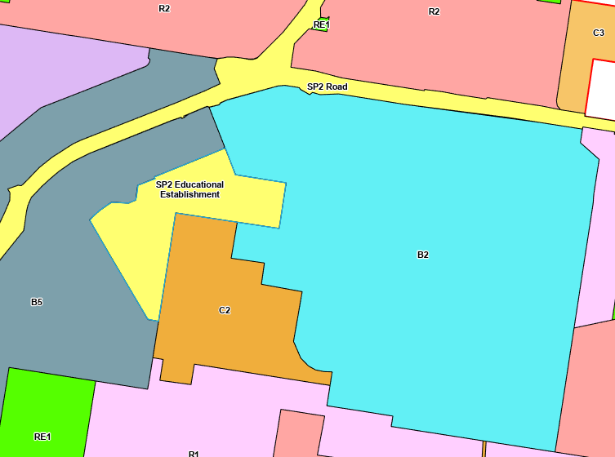

**Figure 7-Zoning Map**

According to the definitions in Clause 4 (contained in the Dictionary), the proposal satisfies the definition of educational establishment which is a permissible use with consent in the Land Use Table in Clause 2.3.

***educational establishment*** means a building or place used for education (including teaching), being—

(a)  a school, or

(b)  a tertiary institution, including a university or a TAFE establishment, that provides formal education and is constituted by or under an Act.

The zone objectives include the following (pursuant to the Land Use Table in Clause 2.3):

•  To provide for infrastructure and related uses.

•  To prevent development that is not compatible with or that may detract from the provision of infrastructure.

•  To recognise existing railway land, major roads and utility installations and to enable their future development and expansion.

The proposal is considered to be consistent with these zone objectives for the following reasons:

* The proposal is for a new building which is related to the school operations.
* The proposal is compatible with and enhances the existing school operation.
* The proposal is compatible with and will not significantly impact the surrounding development or road system.

**General Controls and Development Standards (Part 2, 4, 5 and 6)**

The LEP also contains controls relating to development standards, miscellaneous provisions and local provisions. The controls relevant to the proposal are considered in **Table 4** below.

**Table 4: Consideration of the LEP Controls**

|  |  |  |  |
| --- | --- | --- | --- |
| **Control** | **Requirement** | **Proposal** | **Comply** |
| Minimum subdivision Lot size  (Cl 4.1) | N/A |  | N/A |
| Height of buildings  (Cl 4.3(2)) | N/A |  | N/A |
| FSR  (Cl 4.4(2)) | N/A |  | N/A |
| Land acquisition (Cl 5.1/5.1A) | N/A |  | N/A |
| Heritage  (Cl 5.10) | N/A |  | N/A |
| Acid sulphate soils  (Cl 6.1) | Class 5 | Limited excavation is proposed which is unlikely to impact ASS or groundwater. The submitted geotechnical report by Martens concludes that although the proposed development will involve excavation up to 2m below ground level the site poses a very low ASS risk. The site is considered suitable for the proposed development and no further investigation is considered necessary. Refer condition 5.7. | Yes |
| Flood planning (Cl 6.3) | Not impacted by flooding |  | Yes |
| Stormwater Management (Cl 6.4) | Stormwater management Plan submitted |  | Yes |

The proposal is considered to be generally consistent with the CCLEP 2022.

1. **Section 4.15 (1)(a)(ii) - Provisions of any Proposed Instruments**

There are several proposed instruments which have been the subject of public consultation under the EP&A Act, and are relevant to the proposal, including the following:

* *Draft SEPP (Environment) 2017*
* *Draft SEPP (Short Term Rental Accommodation) 2019*

These proposed development does not involve any removal of native vegetation and is not for residential development and is not impacted by the draft SEPPs.

The proposal is generally consistent with these proposed instruments.

1. **Section 4.15(1)(a)(iii) - Provisions of any Development Control Plan**

The following Development Control Plan is relevant to this application:

* *Central Coast Development Control Plan 2022.*

Chapter 2.13 Transport and Parking

|  |  |  |  |
| --- | --- | --- | --- |
| Clause | Required | Comment | Compliance |
| 2.13.3 | A traffic management plan is required where a variation to carparking is proposed. | The proposal does not increase the number of students or staff and there is no increase in demand for parking. A Construction Management Plan is required while work is being carried out on site. **Refer condition 4.5.** | Yes |
| 2.13.3.2 | Carparking-educational establishments | The proposal does not increase the number of students or staff and there is no increase in demand for parking. The existing bus stop and kiss and ride facilities are to be retained. | Yes |
| 2.13.3.7 | Parking and access for the disabled | Three disabled spaces are relocated to the western side of the car parking area off Penrose Crescent which provides easy access to the new resources hub. | Yes |

Chapter 2.14 Waste Management

A waste management plan has been submitted for the demolition and construction stages of the proposed development.

Chapter 2.17 Character and Scenic Quality

The site is located within the Erina Landscape Unit. The urban areas are considered to have low visual sensitivity. As the proposed 3 storey resources hub are located within the school grounds and away from the main roads there are opportunities for increased density and scale and the proposed development does not impact the scenic quality of the area.

The site is also located within Erina 12: Community Centres + Schools where the desired character is:

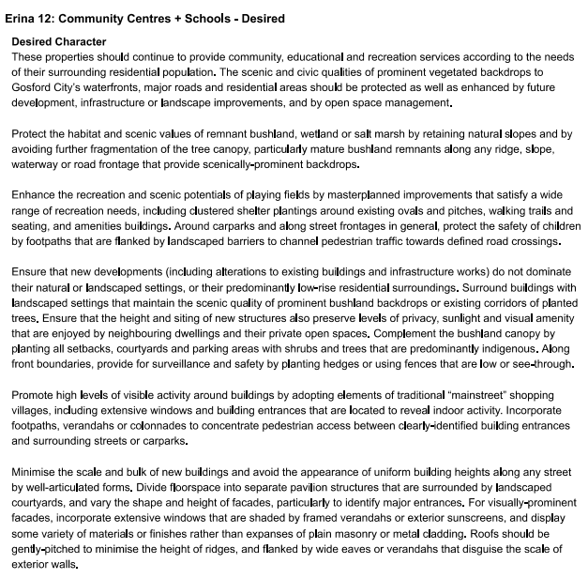

The proposal is consistent with the existing and desired character as:

* The site will continue to be used for educational purposes to serve the needs of the wider community.
* The proposal does not require the removal of any substantial vegetation but the replacement of 5 demountable buildings with a purpose-built school building.
* The proposal does not reduce recreation or playing areas on the school site.
* The height, setbacks and design are consistent with and compatible with the existing school buildings and surrounding development.
* The proposed building identifies the main entrance and access to the school with appropriate landscaping.

Chapter 3.1 Floodplain Management

The site of the proposed resources hub is not subject to flooding. A water cycle management plan has been submitted which provides for the runoff from the site to be catered for through the existing nutrient control and stormwater detention on-site system. The water cycle management plan is assessed as satisfactory by Council’s Development Engineer.

Chapter 3.5 Tree and Vegetation

The proposal does not remove any native or substantial vegetation. A landscape plan has been submitted with the application.

The following contributions plans are relevant pursuant to Section 7.18 of the *EP&A Act* and have been considered in the recommended conditions (notwithstanding Contributions plans are not DCPs they are required to be considered):

* *Central Coast Regional Contribution Plan S7.12*

This Contributions Plan has been considered and included the recommended draft consent conditions which require a contribution of 1% of the value of the proposed development. **Refer condition 2.7.**

1. **Section 4.15(1)(a) (iiia) – Planning agreements under Section 7.4 of the EP&A Act**

There have been no planning agreements entered into and there are no draft planning agreements being proposed for the site.

1. **Section 4.15(1)(a)(iv) - Provisions of Regulations**

Section 61 of the 2021 EP&A Regulation contains matters that must be taken into consideration by a consent authority in determining a development application, with the following matters being relevant to the proposal:

* If demolition of a building proposed - provisions of AS 2601. The proposed demountables are proposed to be sold and removed from the site. Some minor demolition will be required such as removal of existing footings, concrete paths.

Section 62 (consideration of fire safety) and Section 64 (consent authority may require upgrade of buildings) of the 2021 EP&A Regulation are not relevant] to the proposal.

These provisions of the 2021 EP&A Regulation have been considered and are addressed in the recommended draft conditions (where necessary).

* 1. **Section 4.15(1)(b) - Likely Impacts of Development**

The likely impacts of that development, including environmental impacts on both the natural and built environments, and social and economic impacts in the locality must be considered. In this regard, potential impacts related to the proposal have been considered in response to SEPPs, LEP and DCP controls outlined above and the Key Issues section below.

The consideration of impacts on the natural and built environments includes the following:

* Context and setting – The proposal is considered to be generally consistent with the context of the school site, in that the proposed building is an appropriate scale, mass, form, and in character with existing and surrounding development.
* Access and traffic – The proposed building does not result in any additional traffic or parking generation, or impact on public transport or capacity of the road network. The temporary impacts on the school operation and external road system will be mitigated by a construction management plan which will relocate drop off/pick up to the Karalta Lane entry. **(Refer condition 4.5)**
* Public Domain – The proposal will not impact the public domain. There is no public open space adjoining the site except for public road system.
* Utilities – All utilities are available to the site.
* Heritage – The site and adjoining lands do not contain any heritage items.
* Other land resources – The proposed building location is not located near any creeks or watercourses.
* Water/air/soils impacts – The site has been used as a school since 1973 and past use is unlikely to result in contamination.
* Flora and fauna impacts – There is no native tree or vegetation removal and no impact on threatened species or biodiversity. The proposed resources hub is located on the site of existing demountable buildings which are to be removed.
* Natural environment – There are no significant changes to the contours of the site. There is minor cut/fill less than about 1m in the area already occupied by the demountable buildings.
* Noise and vibration – An acoustic report has been submitted that recommends measures for noise mitigation within the school. There are no sensitive developments such as residential on the adjoining sites which are mainly commercial/retail. **(Refer condition 2.6 and 6.9)**
* Natural hazards – The site is affected by bushfire from the bushland within Erina Fair shopping centre to the south. A consultant bushfire assessment has been submitted and the NSW Rural Fire Service have issued GTAs under Section 100B of the Rural Fires Act 1997, subject to conditions. This includes the buildings being to Bal 19 standard and an emergency evacuation plan in place for the school. (Refer Attachment A)
* Safety, security and crime prevention – CPTED Principles are addressed by conditions of consent. **(Refer attachment A Condition 6.10)**
* Social impact – The proposal will provide improved amenities and facilities for the existing school. The new building will aid the health and safety of the school community and provide a sense of place.
* Economic impact – The proposal will generate additional employment during construction which will have some local economic benefits for local businesses.
* Site design and internal design – The proposed resources hub is located in the existing location of the existing demountable buildings which are to be removed.
* Construction – A CMP is required to mitigate internal and external impacts during construction. As the development is not located near sensitive development such as residential dwellings, it is considered the hours of construction should not be restricted to Monday to Saturday to enable the construction works to be carried out as quickly as possible to reduce the time period for construction and hence construction impacts. **(Refer conditions 5.2, 5.11 and 5.12).**
* Cumulative impacts – The proposal is unlikely to have any cumulative impacts. It is consistent with the planning controls, zoning of the land and the objectives of the SP2 zone.

Accordingly, it is considered that the proposal will not result in any significant adverse impacts in the locality as outlined above.

* 1. **Section 4.15(1)(c) - Suitability of the site**

The proposal fits within the locality of the existing school. There are adequate services, public transport, on site parking and playing fields.

The bush fire risk from adjoining land is mitigated by construction standards and conditions imposed by the Rural Fire Service.

There are no adjoining use which impact the development and the surrounding uses are compatible with the school use.

* 1. **Section 4.15(1)(d) - Public Submissions**

There were no public submissions to the proposed development.

* 1. **Section 4.15(1)(e) - Public interest**

Approval of the proposal is in the public interest. It will provide upgraded and improved educational and technical facilities for the school and the community.

The proposal is consistent with the principles of Ecologically sustainable development,

Climate change.

Om balance the proposal is consistent with the public interest.

1. **REFERRALS AND SUBMISSIONS** 
   1. **Agency Referrals and Concurrence**

The development application has been referred to various agencies for comment/concurrence/referral as required by the EP&A Act and outlined below in Table 5.

There are no outstanding issues arising from these concurrence and referral requirements subject to the imposition of the recommended conditions of consent being imposed.

**Table 5: Concurrence and Referrals to agencies**

|  |  |  |  |
| --- | --- | --- | --- |
| **Agency** | **Concurrence/**  **referral trigger** | **Comments**  **(Issue, resolution, conditions)** | **Resolved** |
| Concurrence Requirements (s4.13 of EP&A Act) | | | |
| Environment Agency Head (Environment, Energy & Science Group within DPIE) | S7.12(2) - *Biodiversity Conservation Act 2016* | N/A | N/A |
| Rail authority for the rail corridor | Section 2.98(3) - *State Environmental Planning Policy (Transport and Infrastructure) 2021* | N/A | N/A |
| Referral/Consultation Agencies | | | |
| Electricity supply authority | Section 2.48 – *State Environmental Planning Policy (Transport and Infrastructure) 2021*  Development near electrical infrastructure | N/A | N/A |
| Rail authority | Section 2.97 – *State Environmental Planning Policy (Transport and Infrastructure) 2021*  Development land that is in or adjacent to a rail corridor. | N/A | N/A |
| Transport for NSW | Section 2.121 – *State Environmental Planning Policy (Transport and Infrastructure) 2021*  Development that is deemed to be traffic generating development in Schedule 3. | N/A | N/A |
| Design Review Panel | Cl 28(2)(a) – SEPP 65  Advice of the Design Review Panel (‘DRP’) | N/A | N/A |
| Integrated Development (S 4.46 of the EP&A Act) | | | |
| RFS | S100B - *Rural Fires Act 1997*  bush fire safety of development of land for special fire protection purposes | A bushfire safety authority has been issued subject to conditions. Refer condition 1.3 | Y |
| Natural Resources Access Regulator | S89-91 – *Water Management Act 2000*  water use approval, water management work approval or activity approval under Part 3 of Chapter 3 | N/A | N/A |

* 1. **Council Officer Referrals**

The development application has been referred to various Council officers for technical review as outlined **Table 6.**

**Table 6: Consideration of Council Referrals**

|  |  |  |
| --- | --- | --- |
| **Officer** | **Comments** | **Resolved** |
| Engineering | Council’s Engineering Officer reviewed the submitted stormwater concept plan and considered that there were no objections subject to conditions. See comments below. | Y |
| Traffic | Council’s Traffic Engineering Officer reviewed the proposal and raised no concerns in relation to traffic generation and car parking. | Y |
| Tree Assessment Officer | Plans show removal of one tree located in the vicinity of the proposed works. The tree was found to be a planted *Stralitzia nicholai* (Giant Bird of Paradise).  No objection to removal of this ornamental planting. | Y |
| Environmental Health | Council’s Environmental Health Officer reviewed the submitted erosion and sediment control plan, acoustic report and geotechnical investigation and there were no objections subject to conditions. See comments below. | Y |
| Waste | Waste Management Plan submitted. Site is serviced by private contractor. | Y |
| Public Domain/  Assets | No works are proposed within the public domain or road reserve. | Y |
| Heritage | The proposal does not impact any heritage items | N/A |
| Water and Sewer | Supported subject to conditions. Refer conditions 2.2 and 6.2. | Y |

The issues raised by Council officers are considered in the following section.

**Engineering**

Road works

The site has a frontage to Penrose Crescent which is fully constructed with kerb & gutter on both sides of the road. There is a regulatory “No Stopping” zone across the full frontage of the site in Penrose Crescent. There is concrete footpath across the full frontage of the site in Penrose Crescent.

No road works are required in conjunction with this development proposal.

Access

No changes to access provisions associated with the two existing vehicle access crossings in Penrose Crescent are proposed or required within the road reserve.

Within the site, minor modifications are proposed to the access and parking arrangements. In this regard:

* The kiss and ride area is being maintained in its present location, however this will be undercover as a result of the proposed resources hub building.
* The disabled spaces are being relocated to the western side of associated row of parking to assist in easier entry to the proposed resources hub. These spaces will need to be reconstructed to reduce the grades of these spaces to the maximum permitted under AS2890.6:2009, and to provide line marking consistent with the requirements of AS2890.1:2009. It is recommended that revised plans be submitted prior to the issue of a development consent to provide the configuration of proposed disabled spaces compliant with AS2890.6:2009.

Internal vehicular access and parking arrangements will need to comply with AS2890, in particular, AS/NZS 2890.1:2004 and AS/NZS 2890.6:2009.

Adjustments to internal pedestrian movements are also proposed including the provision of a new pedestrian crossing.

Traffic

The proposed development is not increasing student numbers. Therefore, referral to TfNSW under Clause 2.121 of SEPP (Transport and Infrastructure) 2021 is not required.

A ‘Traffic and Transport Assessment’ prepared by Transport and Traffic Planning Associates (Ref: 22094 Issue B dated September 2022) was submitted with the application which indicates:

* there will not be any adverse traffic implications resulting from the proposed development.
* the proposed parking provisions will continue to be adequate and appropriate
* the vehicle access, internal circulation and resourcing provisions will continue to be satisfactory.
* turning paths provided for the AS2890.1:2004 B99 vehicle are satisfactory in relation to vehicles entering the site and entering/exiting the set down / pick up area.

Flooding

Although Council’s records indicate that the site is affected by flooding and flood planning controls related to the Erina Creek Flood Study, the area of the site associated with the development proposal and access to Penrose Crescent are not affected by flooding or flood planning controls.

Drainage

A ‘Stormwater Management Plan’ (SMP) prepared by Enscape Studio (Project Ref: 0161 dated 20 September 2022) was submitted with the application that addresses the requirements of Chapter 3.1 Part C of Council’s Gosford DCP2022 as follows:

* Retention. Not addressed. It is recommended that a water tank be provided for capture of roof water for reuse within the development. This can be conditioned with the development consent.
* On Site Detention (OSD) - Water Quantity: A runoff routing method (‘DRAINS’ model) has been utilised to design the requirements for onsite detention for the proposed development. A concrete tank with a volume of 10.24m3 is proposed to be located under the front part of the building entry. The design indicates the proposed OSD system will limit post development flows back to predevelopment flows for the 5%AEP and 1%AEP. It is recommended that final design of the OSD system be conditioned to limit post development flows back to predevelopment flows for all storm recurrence intervals up to and including the 1%AEP recurrence interval, i.e. 20%AEP, 10%AEP, 5%AEP, 2%AEP, & 1%AEP.
* Water Quality. A ‘MUSIC’ model was undertaken to analyse the performance of the proposed pollution reduction elements to be provided in a treatment train approach. The results indicate that the proposed use of 3 x Oceanguards and 2x Stormfilter Cartridges would generally achieve the pollutant reduction criteria required under the DCP.
* Overland flows. Overland flows are being diverted around the proposed building.
* Flooding. The area of the site associated with the proposed development is not subject to flooding or flood planning controls.
* Stormwater plans were provided with the SMP.

It is also noted that an existing pipeline is being reconstructed and diverted around the proposed building.

Stormwater from the proposed development is to connect to the existing stormwater drainage network within the school site.

**Environmental Health**

Air Quality

Dust is expected during the construction period and methods of dust suppression have been provided in the Erosion and Sediment Control Plan.

ASS

The land is mapped as Class 5, no-known occurrence ASS. The construction activities proposed are unlikely to lower the water table in adjacent Class 1-4 lands, therefore further consideration of ASS is not required.

Contamination/ SEPP (Resilience and Hazards) 2021

The current and historic land uses are not potentially contaminating; therefore, the site is considered suitable for the continued use as an educational facility.

Noise

The new building is proposed to operate Monday to Friday 8:30am to 4:00pm.

The Acoustic Report prepared by Acoustic Dynamics, dated 8 September 2022 has been reviewed. The Report has been prepared to determine noise intrusion and to provide advice on internal acoustic privacy and internal and external materials design advice. The Association of Australasian Acoustical Consultants Guideline for Educational Facilities, NSW Department of Education’s Educational Facilities Standards and Guidelines and the AS 2107:2016 and AS 3671:1989 have been used to assess compliance. Recommended design advice has been provided for the external walls, roof, glazing, internal walls, operable walls, glazed partitions, room entry doors, door seals, floors, ceilings, partition junctions, cavity barrier options, acoustic linings, penetrations, speaker and television mounting, mechanical services, and rooftop mechanical plant.

Soils and Construction/Water

The amended Erosion and Sediment Control Plan prepared by Enscape Studio Pty Ltd has been reviewed and is considered adequate.

Bulk earthworks are proposed with 625m3 of cut and 65 m3 of fill, resulting in 560 m3 of excess.

* 1. **Community Consultation**

The proposal was notified in accordance with the CCDCP 2022 *from 11 November 2022 until 2 December 2022. The notification included the following:*

* An advertisement in the local newspaper [name of publication] (where applicable)
* Twelve (12) notification letters sent to adjoining and adjacent properties.
* Notification on the Council’s website.

The Council received no submissions to the proposed development.

1. **KEY ISSUES**

The following key issues are relevant to the assessment of this application having considered the relevant planning controls and the proposal in detail:

* 1. **Construction Impact.**

The proposal does not increase the number of students/staff and will not generate additional traffic/parking during future operation.

The construction period will result in on site disruption and external road impacts during while demolition and construction of the new building is being carried out.

Resolution: The issue has been resolved through recommended conditions of consent as outlined in **Attachment A- condition 4.5**.

* 1. **Urban Design**

The proposed building form presents a sympathetic response to the streetscape and the internal school layout and existing buildings. A proposed elevated walkway connects the proposed building to the existing buildings. The proposed building is not of an excessive bulk and scale and positively contributes to the desired future character of the area.

The proposed building has sufficient setbacks and facade articulation to Penrose Crescent.

The design of the proposed facades to both the side and rear boundaries are considered acceptable as the proposal presents as a 3-storey building compatible with other school buildings remaining.

The proposed use of a flat sloping roof form mitigates the visual appearance of the proposal.

The external appearance is well articulated with variable materials and colours.

* 1. **Noise Assessment**

The potential for noise impact on the school environment is an important consideration given the proximity to main roads and Erina Fair shopping centre.

The application was accompanied by an Acoustic Assessment prepared by Acoustic Dynamics. dated 8 September 2022 which considered this issue.

Acoustics Dynamics conducted an assessment of noise intrusion and internal acoustic privacy for the proposed Resources Hub within the school site in accordance with the requirements of:

* Central Coast Council
* NSW Department of Planning and Infrastructure
* NSW Department of Education
* Australian Standards
* AAAC Guidelines.

The noise assessment concludes that subject to the incorporation of the recommendations of the Acoustic report the proposed development will achieve compliance with the relevant acoustic design requirements of Council, the NSW Department of Planning and Infrastructure, Australian standards and AAAC guidelines.

Resolution: The issue has been resolved through recommended conditions of consent as outlined in **Attachment A (Conditions 2.6, 5.2, 5.11, 5.12 and 6.9)**.

**5.4. Bushfire Risk**

The school site is identified as bushfire prone land. Schools are listed as sensitive development and are a Special Fire Protection Purpose under section 100b of the *Rural Fires Act* 1997. As such the development is classified as integrated development under section 4.46 of the Environmental Planning and Assessment Act 1979 as it requires the approval of the NSW Rural Fire Service. **(Refer condition 1.3)**

A Bushfire Assessment Report has been submitted prepared by Building Code & Bushfire Hazards Solutions Pty Ltd dated 31 August 2022.

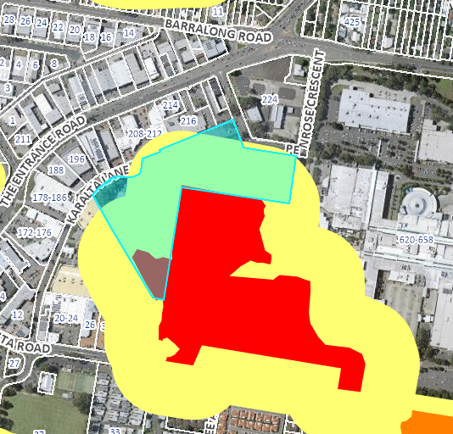

**Figure 8-Bush Fire Prone Land**

The bushfire assessment report identifies:

- The vegetation identified as posing a bush fire hazard to the proposed resources hub is located to the south within the Erina Fair site.

- The current demountable buildings were installed prior to planning for bushfire planning controls.

- The APZ of 48m to the south is located partly within the site and 10m within the Erina Fair property. Erina Fair has a Bushfire Management Plan (Ref. No. 120082B dated 8 May 2002 that maintains the 10m area as an APZ.

- All new construction must comply with BAL 19 under PBP.

- The awning attached to the multi-purpose hall within the APZ shall be constructed entirely of non-combustible materials.

The NSW Rural Fire Service issued a Bush Fire Safety Authority under section 100B of the Rural Fires Act 1997 on 12 December 2022, subject to conditions. **(Refer attachment C)**

In summary the GTA require:

a. The entire property to be managed as an IPA for a distance of 100m or to the property boundary whichever occurs first.

b. New Construction to comply with BAL 19 and the proposed awning to the existing multi-purpose hall must be constructed of non-combustible materials.

c. An updated Bush Fire Emergency Management and Evacuation Plan.

Resolution: The issue has been resolved through recommended conditions of consent as outlined in **Attachment A - Condition 1.3**.

1. **CONCLUSION**

This development application has been considered in accordance with the requirements of the EP&A Act and the Regulations as outlined in this report. Following a thorough assessment of the relevant planning controls, issues raised in submissions and the key issues identified in this report, it is considered that the application can be supported.

The proposal does not increase staff or student numbers. The replacement of the existing demountable buildings with a new 3 storey resources hub will improve the operation and efficiency of the school, as well as the internal and external appearance.

The location of the Resources hub in the location of the existing demountable buildings improves the current situation with the removal of demountable buildings and the design is compatible with the surrounding development.

The proposal provides for stormwater collection and disposal to the existing street system and

will be constructed in accordance with current bushfire measures as approved by the NSW Rural Fire Service.

The likely internal and external impacts during construction can be mitigated by a construction management plan (CMP) which is required as a condition of consent. (**Refer conditions 5.2, 5.11 and 5.12**). The school will relocate all drop off/pick up while construction is being carried out to the south of the site off Karalta Lane.

There were no public objections submitted to the proposal.

It is considered that the key issues as outlined in Section 6 have been resolved satisfactorily in the recommended draft conditions at **Attachment A**.

1. **RECOMMENDATION**

That the Development Application DA/3119/2022 for Demolition of five (5) demountable buildings and construction of a three storey resources hub within the grounds of the Central Coast Adventist School at Lot 82 DP 1108157 [12 Penrose Crescent, Erina] be APPROVED pursuant to Section 4.16(1)(a) of the *Environmental Planning and Assessment Act 1979* subject to the draft conditions of consent attached to this report at Attachment A.

The following attachments are provided:

* Attachment A: Draft Conditions of consent. (D 15501256)
* Attachment B: Architectural Plans (D15412377 except sheets DA 102 and DA201, D15361877, D15361880)
* Attachment C: GTA NSW Rural Fire Service (D15474890)